13.2.6 Claims Windows

This Window section contains a list of the functional groups and a brief description of each. The Claims subsystem uses a number of Windows that are identified by purpose of use or Functional Group. The online functional groups in the PDCS OS PLUS Claims subsystem listed in this section are:
- The Credit functional group contains windows that allow the user to enter batches of claim reversals submitted on paper adjustment request forms. A credit batch control record must be on file prior to the entry of a batch of credits.
- The Inquiry functional group contains windows that allow the user the ability to search for and display detail information about a pharmacy claim.
- The Suspense Correction windows allow the user to enter selection criteria to retrieve and correct suspended claims.
- The Suspense Release functional group contains windows that allow the user to enter requests to release suspended claims to adjudicate or to delete a batch of claims. These requests are processed during the nightly adjudication processing. These windows also allow the user to search for and update these requests.
- The History Adjustment Search window provides the user with the ability to enter selection criteria to retrieve history adjustment claims.
Each of these is described in detail separately, beginning below.

13.2.6.6 Credit Functional Group

This functional group provides the user the ability to:

- Locate the Credit Batch Control record
- Search for the claim to be reversed
- Adjudicate the claim

The following tab windows are used by the Credit Functional Group:

- Credit Batch Search
- Credit Information

The following data is displayed in the title bar of all tab windows (i.e., not on search windows) in this functional group:

- Customer name and TCN

New Mexico PDCS OS PLUS Claims Subsystem
Window Specification
Credit Functional Group
Credit Batch Search Window

Window Name: Credit: Credit Batch Search
Description:
The Credit Batch Search window allows the user to enter selection criteria to locate the Batch Control record related to a batch of credits to be exam entered. The Batch Date is required. The Batch Number field can be used to refine the search. Information for all batches with the specified batch date is displayed in the list box.

Window Type:
Response Window

Navigation:
The user enters this window by selecting the Credit option from the Claims subsystem menu. The user must click on the Batch key to proceed to the credit information window.

Interface to Other Subsystem(s):
N/A

Interface to Other Application(s):
N/A

Special Security Requirements:

Presentation Sequence(s):
The system displays the data sorted by Batch Key in ascending order.

Remarks:
The Credit Functional Group has only 2 windows: Credit Batch Search and the Credit Information (displayed after selecting the batch key from the Credit Batch Search window). The following tabs displayed on the Credit Batch Search window are not used by the Credit Functional Group: Doc List, Claim, Line Items, Misc. Fields, Misc. Tables, and History.

New Mexico PDCS OS PLUS Claims Subsystem
Window Layout
Credit Functional Group
Credit Batch Search Window

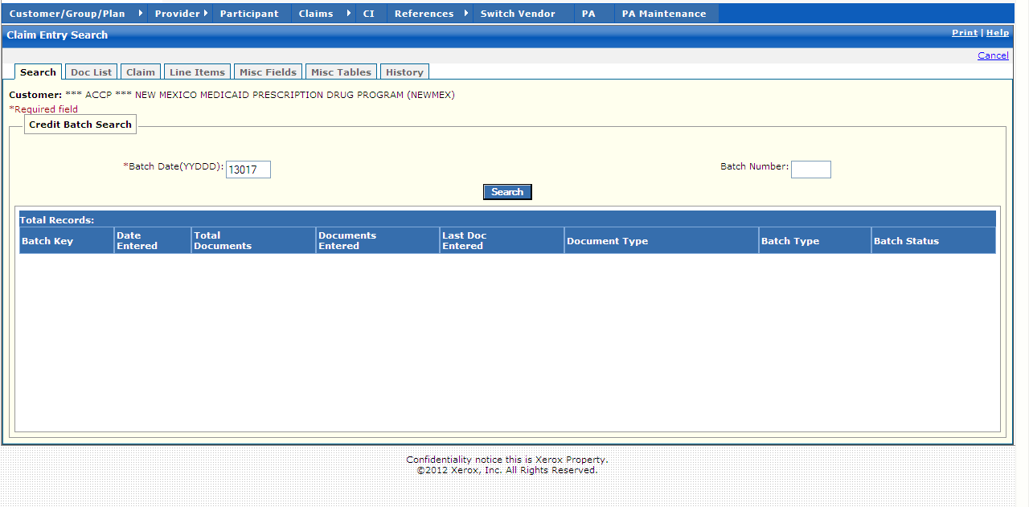

New Mexico PDCS OS PLUS Claims Subsystem
Window Exhibit
Credit Functional Group
Credit Batch Search Window
Field Name | Table Column Name | Table Name | Format | Prot. (A,C,N) | Req.  (A,C,N) | Std. Edits | Specifications | Note  Ref.
Customer | R-CUST-PART-NUM | B_DETAIL_NM | 9,999 | A | N/A | N/A | Display Header
Credit Batch Search Entry | Group | N/A | Group | N/A | N/A | N/A | Grouping
Batch Date  (YYDDD) | C_BAT_JLN_DT_NUM | C_BAT_CNTL_TB | 9(5) | N | A | D | Format: YYDDD  (Julian Date)  Must be a valid date
Batch Number | C_BAT_NUM | C_BAT_CNTL_TB | 9(4) | N | C | N | Must be 4 digits
Command Button | Group | N/A | Button Row | N/A | N/A | N/A | Grouping
Search | N/A | N/A | Push Button | N | N | N/A | When pressed, batches meeting the Search Criteria entered by the user are displayed in the list box
Credit Batch Search Display | Group | N/A | Group | N/A | N/A | N/A | Grouping
Batch Key | C_BAT_MED_SRC_CD  C_BAT_JLN_DT_NUM  C_BAT_NUM | C_BAT_CNTL_TB | X(1)  9(5)  9(4) | A | N | N/A | Valid Value 0142 Concatenation of Medium Indicator, Batch Date and Batch Number
Date Entered | C_BAT_ENTRY_DT | C_BAT_CNTL_TB | DATE | A | N | N/A | Format: MM/DD/CCYY
Total Documents | C_BAT_DOC_CNT_NUM | C_BAT_CNTL_TB | 9(9) | A | N | N/A
Documents Entered | C_DOC_ENTR_CNT_NUM | C_BAT_CNTL_TB | 9(9) | A | N/A | N/A
Last Doc Entered | C_LAST_ENTRD_NUM | C_BAT_CNTL_TB | 9(9) | A | N | N/A
Document Type | C_BAT_DOC_TY_CD | C_BAT_CNTL_TB | X(1) | A | N | N/A | Valid Value 0161
Batch Type | C_BAT_TY_CD | C_BAT_CNTL_TB | X(1) | A | N | N/A | Valid Value 0140
Batch Status | C_BAT_STAT_CD | C_BAT_CNTL_TB | X(1) | A | N | N/A | Valid Value 0122
Total Records | N/A | N/A | Display | A | N | N/A | Computed as total number of records meeting the search criteria

Legend
Prot. and Req. | Standard Edits | Note Ref.
A = Always | D = Date Edit | C = Customer-specific field or functionality
C = Conditionally | N = Numeric Edits | R = Note Reference
N = Never | S = System Generated
 | V = Valid Value Edit

Ref. No. | Notes
N/A | N/A
New Mexico PDCS OS PLUS Claims Subsystem
Window Specification
Credit Functional Group
Credit Information Window

Window Name: Credit: Credit Information
Description:
The Credit Information window is presented to authorize users to credit a previously submitted claim.

The Credit Information Window opens with a new system-generated TCN for the credit claim. The user may enter either the TCN of the original claim to be credited OR the Provider ID, Provider ID Type, Rx #, and Date Filled. The Group ID and credit reason code are also required.

Window Type:
Response Window

Navigation:
The user enters this window by selecting the batch key from the Credit Batch Search window. After entering all the required information to locate the claim to be reversed, the user selects the Credit button.

Interface to Other Subsystem(s):
N/A

Interface to Other Application(s):
N/A

Special Security Requirements:
Access to data is controlled by the user’s security profile.

Presentation Sequence(s):
N/A

Remarks:
The credit claim contains the TCN of the original claim. The original claim contains the TCN of the credit claim.

New Mexico PDCS OS PLUS Claims Subsystem
Window Layout
Credit Functional Group
Credit Information Window

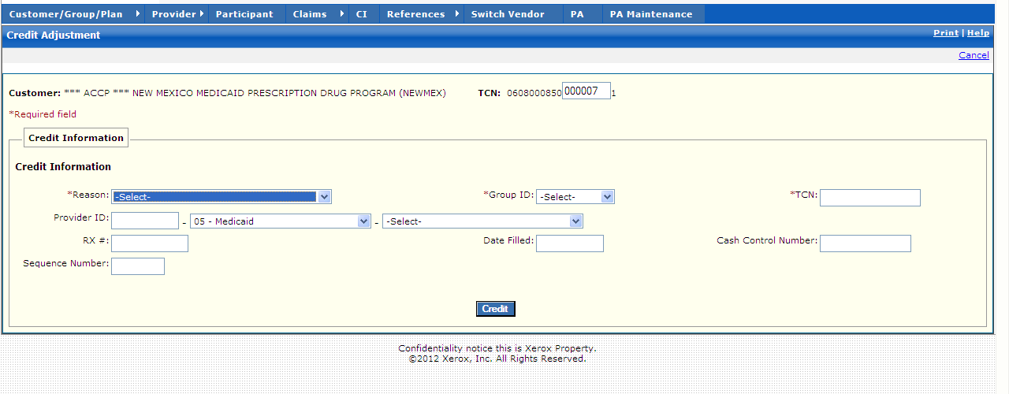

New Mexico PDCS OS PLUS Claims Subsystem
Window Exhibit
Credit Functional Group
Credit Information Window
Field Name | Table Column Name | Table Name | Format | Prot. (A,C,N) | Req.  (A,C,N) | Std. Edits | Specifications | Note  Ref.
Customer | R-CUST-PART-NUM | B_DETAIL_NM | 9,999 | A | N/A | N/A | Display Header
TCN | C_TCN_NUM | C_LI_DRUG_TB | X(17) | A | N/A | N/A | Displays the Transaction control number of particular claim.
Credit Information | Group | N/A | N/A | N/A | N/A | N/A | Grouping
Reason | C_HDR_ADJ_RSN_CD | C_HDR_ADJ_VD_TB | Drop-down | N | A | V | Valid Value 0961
Provider ID -  Provider Type  (unlabeled)  Provider ID Source  (unlabeled) | P_ALT_ID  P_ALT_ID_CD  P_ALT_ID_TY_CD | C_ALT_IX_RX_NUM_TB | X(15),  Drop-down  Drop-down | N  N  N | V  N  N | N/A  V  V | Valid Value 0204  Valid Value 0486 | R1
RX # | C_RX_SVC_REF_NUM | C_LI_DRUG_TB | 9(12) | N | C | N | If entered, value must match Original Claim value. | R1
Sequence Number | C_ADJ_SEQ_NUM | C_HDR_ADJ_VD_TB | 9(4) | N | N | N
Group ID | N/A | N/A | Drop-down | N | A | N/A | Value must match Original Claim value | R1
Date Filled | C_HDR_SVC_FST_DT | C_LI_DRUG_TB | DATE | N | C | D | Format: MM/DD/CCYY  If entered, value must match Original Claim value. | R1
TCN | C_TCN_NUM | C_LI_DRUG_TB | X(17) | N | C | N | If entered, value must match Original Claim value. | R1
Cash Control Number | C_CUST_FCN_NUM | C_HDR_ADJ_VD_TB | X(20) | N | N | N
Command Buttons | Group | N/A | N/A | N/A | N/A | N/A | Group
Credit | N/A | N/A | Push Button | N | N | N/A | When selected, this button searches the Claim database and credits the claim entered.

Legend
Prot. and Req. | Standard Edits | Note Ref.
A = Always | D = Date Edit | C = Customer-specific field or functionality
C = Conditionally | N = Numeric Edits | R = Note Reference
N = Never | S = System Generated
 | V = Valid Value Edit

Ref. No. | Notes
R1 | The user can enter the TCN of the original claim, or the Provider ID, Provider Type, Rx, and Date Filled to find the matching original claim.

13.2.6.7 Inquiry Functional Group

This functional group provides the user the ability to:

- Access detail information about a claim

The following tab windows are used by the Claim Inquiry Functional Group:

- Search
- Claim
- Line Items
- Misc. Fields
- Misc. Tables
- History

Note that the PDCS OS PLUS “CI” menu selection provides a shortcut to access the claim inquiry functional group. Clicking the “CI” selection takes the user to the Claim Inquiry Search window, just as if the user clicked on the Claims menu and then chose the Inquiry functional group. This functionality was designed for greater efficiency by Conduent call center staff assisting with claim issues.

The following data is displayed in the title bar of all tab windows (i.e., not on search windows) in this functional group:

- Customer name, Participant ID, and TCN

New Mexico PDCS OS PLUS Claims Subsystem
Window Specification
Inquiry Functional Group
Claim Inquiry Search Window

Window Name: Inquiry: Claim Inquiry Search
Description:
The Claim Inquiry Search window enables the user to specify search criteria for existing claims. The user searches for claims by entering a combination of primary and secondary search criteria.

Primary: Secondary:
Participant ID Pharmacy ID or Rx ID
Pharmacy ID Participant ID or Rx ID
TCN N/A

For New Mexico, Participant IDs must be entered in a 14-digit format. If using a 9- or 10-digit Participant ID, the user must add leading zeros to make a 14-digit ID.

A Date of Service range can be entered to refine Pharmacy ID and Participant ID searches. (The Date of Service “from” field defaults to the first day of the current month; the “to” date defaults to the current date.)

Pharmacy ID searches can be further qualified by Prescriber or Member Number, Claim Status and Type.
Window Type:
Response Window
Navigation:
The user enters this window by selecting the Inquiry option from the Claims subsystem menu, or by clicking the “CI” menu button.

If more than one claim matches the search results, the user clicks on the status link for a Participant ID search or the Type link for a Pharmacy ID to proceed to the claim information window.
Interface to Other Subsystem(s):
PDCS OS PLUS PA (via link)
Interface to Other Application(s):
N/A
Special Security Requirements:
N/A
Presentation Sequence(s):
Transaction Control Numbers are listed in descending order. Claims returned by a Pharmacy ID search can be sorted by Claim Status, Participant ID, First Service Date, Paid Date, TCN, Drug, Adjudicated Date, or Participant Name by clicking on the underlined column heading. Claims returned by a Participant ID search can be sorted by Claim Status, TCN, First Service Date, Adjudicated Date, Drug, or Provider Name by clicking on the underlined column heading.
Remarks:
The contents of the search results list box vary by type of primary search. The results on the following window are displayed for a Participant ID search.

New Mexico PDCS OS PLUS Claims Subsystem
Window Layout
Inquiry Functional Group
Claim Inquiry Search Window

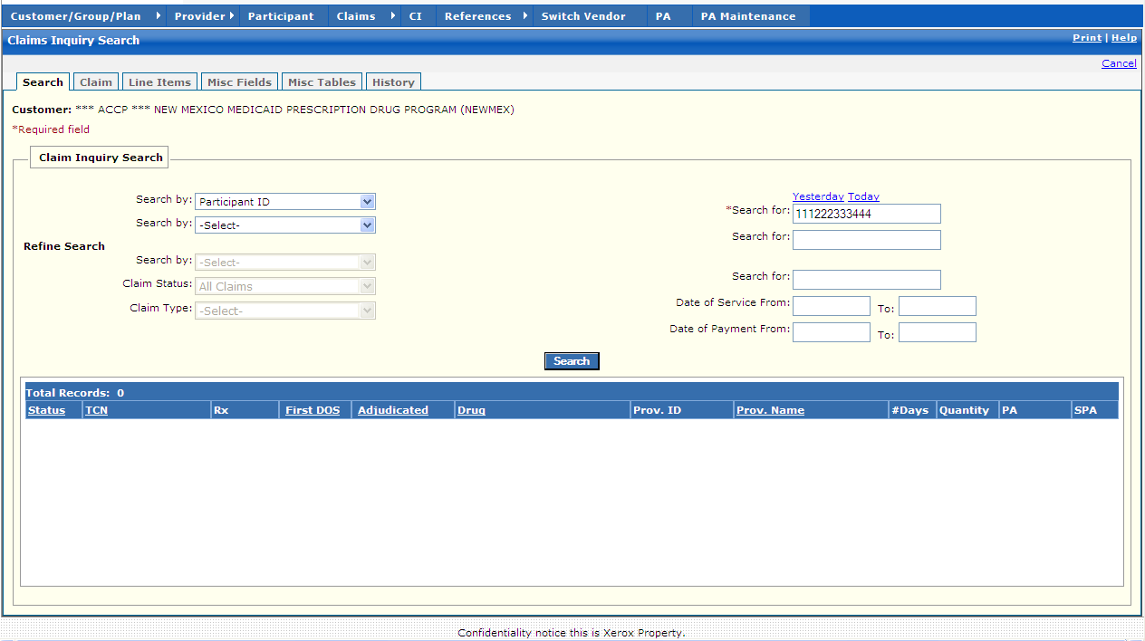

New Mexico PDCS OS PLUS Claims Subsystem
Window Exhibit
Inquiry Functional Group
Claim Inquiry Search Window
Field Name | Table Column Name | Table Name | Format | Prot. (A,C,N) | Req.  (A,C,N) | Std. Edits | Specifications | Note  Ref.
Customer | R_CUST_NAM & R_CUST_ID | R_CUST_DTL_TB | Display | A | N | N/A | This field is populated based on the Customer ID chosen upon login.
Participant | B_LAST_NAM  B_FST_NAM  B_MI_NAM  B_ALT_ID | B_DETAIL_NM  B_ALT_ID_TB | Display | N | N | N/A | This field is populated after a search is performed. If the search returns valid results the participant name and ID are populated.
Claim Inquiry Search Entry | Group | N/A | Free Form | N/A | N/A | N/A | Grouping
Search By (1) | N/A | N/A | Drop-down | N | N | N/A | User must select a primary Search By option. Defaults to Participant ID.  Valid Options are:  TCN  Pharmacy ID  Participant ID
Search By (2) | N/A | N/A | Drop-down | N | N | N/A | Second set of search criteria. Used in conjunction with the primary Participant ID and Pharmacy ID Search By and Search For values. Valid Options are:  Pharmacy ID  Participant ID  Prescription ID  <none for TCN>
Yesterday | N/A | N/A | Link | N | N | N/A | Displays previous day’s Julian date in search for field for TCN search.
Today | N/A | N/A | Link | N | N | N/A | Displays Current Julian date in search for field for TCN search.
Search For (1) | N/A | N/A | N/A | N | A | S | Enter a Pharmacy ID, Participant ID, or TCN, based on the Search By option chosen. | C1
Search For (2) | N/A | N/A | N/A | N | C | S | Enter a Pharmacy ID, Participant ID, or Prescription ID, based on the Search By option chosen.
Refine Search | N/A | N/A | Display | N/A | N/A | N/A | Grouping
Search by | N/A | N/A | Drop-down | N | N | N/A | If entered, criterion is used in combination with the values in the primary and secondary search criteria fields to search for claims. Valid Options are:  Prescribing ID  Member Number  <none for TCN>
Claim Status | N/A | N/A | Drop-down | N | N | V | Valid Value 1020  Valid selection values are displayed in drop-down list.
Claim Type | N/A | N/A | Drop-down | N | N | V | Valid Value 1031  Valid selection values are displayed in drop-down list.
Search For | N/A | N/A | N/A | N | C | S | Enter a Prescribing ID or Member Number, based on the Search By option chosen.
Date of Service From | N/A | N/A | DATE | N | C | D | Format: MM/DD/CCYY  User enters an earliest search date of service.  Must be a valid date | R1
Date of Service To | N/A | N/A | DATE | N | C | D | Format: MM/DD/CCYY  User enters an earliest search date of service.  Must be a valid date | R1
Date of Payment From | N/A | N/A | DATE | N | C | D | Format: MM/DD/CCYY  User enters an earliest search payment date.  Must be a valid date
Date of Payment To | N/A | N/A | DATE | N | C | D | Format: MM/DD/CCYY  User enters an earliest search payment date.  Must be valid date
Command Button | Group | N/A | Free  Form | N/A | N/A | N/A | Grouping
Search | N/A | N/A | Push Button | N | N | N/A | When pressed, claims meeting the Search Criteria entered by the user are displayed in the list box.
Claim Inquiry Search Display | Group | N/A | Grid | N/A | N/A | N/A | Grouping  This is a Participant ID Search format
Status | C_HDR_STAT_CD | C_LI_DRUG_TB | X(1) | A | N | N/A | Valid Value 1020
TCN | C_TCN_NUM | C_LI_DRUG_TB | X(17) | A | N | N/A
Rx | C_RX_SVC_REF_NUM | C_LI_DRUG_TB | 9(12) | A | N | N/A
First DOS | C_HDR_SVC_FST_DT | C_LI_DRUG_TB | DATE | A | N | N/A | Format: MM/DD/CCYY
Adjudicated | C_HDR_ADJUD_DT  C_ADJUD_TM | C_LI_DRUG_TB  C_HDR_TB | DATE  TIME | A | N | N/A
Drug | R_DRUG_CD | C_LI_DRUG_TB | X(11) | A | N | N/A
Prov. ID | P_SVC_PHARM_ALT_ID | C_LI_DRUG_TB | X(15) | A | N | N/A
Prov. Name | P_NAM | P_PROV_TB | X(35) | A | N | N/A
#Days | C_SUB_DAY_SPLY_AMT | C_LI_DRUG_TB | 9(3) | A | N | N/A
Quantity | C_SUBM_ING_QTY_AMT | C_LI_DRUG_TB | 9(11,3) | A | N | N/A
PA | N/A | N/A | Link | N | N | N/A | Click on this link to search for PAs on file for the participant.
SPA | C_SPA_PRCS_CD | C_LI_DRUG_TB | X(1) | A | N | N/A | If the claim was processed with the Smart PA system.
Total Records | N/A | N/A | Display | A | N | N/A | Computed as total number of records meeting the search criteria

Legend
Prot. and Req. | Standard Edits | Note Ref.
A = Always | D = Date Edit | C = Customer-specific field or functionality
C = Conditionally | N = Numeric Edits | R = Note Reference
N = Never | S = System Generated
 | V = Valid Value Edit

Ref. No. | Notes
R1 | Defaults to current date.
C1 | For New Mexico, Participant IDs must be entered in a 14-digit format. If using a 9- or 10-digit Participant ID, the user must add leading zeros to make a 14-digit ID.
New Mexico PDCS OS PLUS Claims Subsystem
Window Specification
Inquiry Functional Group
Claim Tab Page

Window Name: Inquiry: Claim
Description:
The Claim Exception/Information window is presented to authorized users to view pharmacy claim data. Authorized users can view claims information immediately following adjudication.

The Exceptions section of the window displays internal and external codes for any exceptions encountered during adjudication processing. This information is present for denied claims as well as for paid claims that have exceptions set to “pay and report” or “pay on review”.

The Claim Information section of the window consists of the following panes.

- The Participant pane displays information about the Participant such as Participant Name, Date of Birth, and Participant ID.
- The Provider pane displays the Pharmacy, Primary Care Physician, and Prescriber ID information.
- The COB pane displays Coordination of Benefits information.
- The Rx Information pane displays information pertaining to the prescription or Service.
- The Pricing Pane displays Pricing information such as Ingredient Cost, Total Charge, Dispensing fee, Copay, and Paid amount.
- The Other Information pane displays Override information.
- The User ID, Group, Claim Status, etc. are displayed at the bottom of window.

Window Type:
Response Window
Navigation:
The user enters this window by clicking the “Type” or “Status” link on the Claim Inquiry Search window. The user may also enter this window by selecting the SHOW CLAIMS link for a Participant from the Participant subsystem.
Interface to Other Subsystem(s):
PDCS OS PLUS Participant, Provider, Customer/Group/Plan, Reference/Drug – Via links
Interface to Other Application(s):
N/A
Special Security Requirements:
N/A
Presentation Sequence for Exceptions:
Line Item number, Exception Number
Remarks:
N/A

New Mexico PDCS OS PLUS Claims Subsystem
Window Layout
Inquiry Functional Group
Claim Tab Page

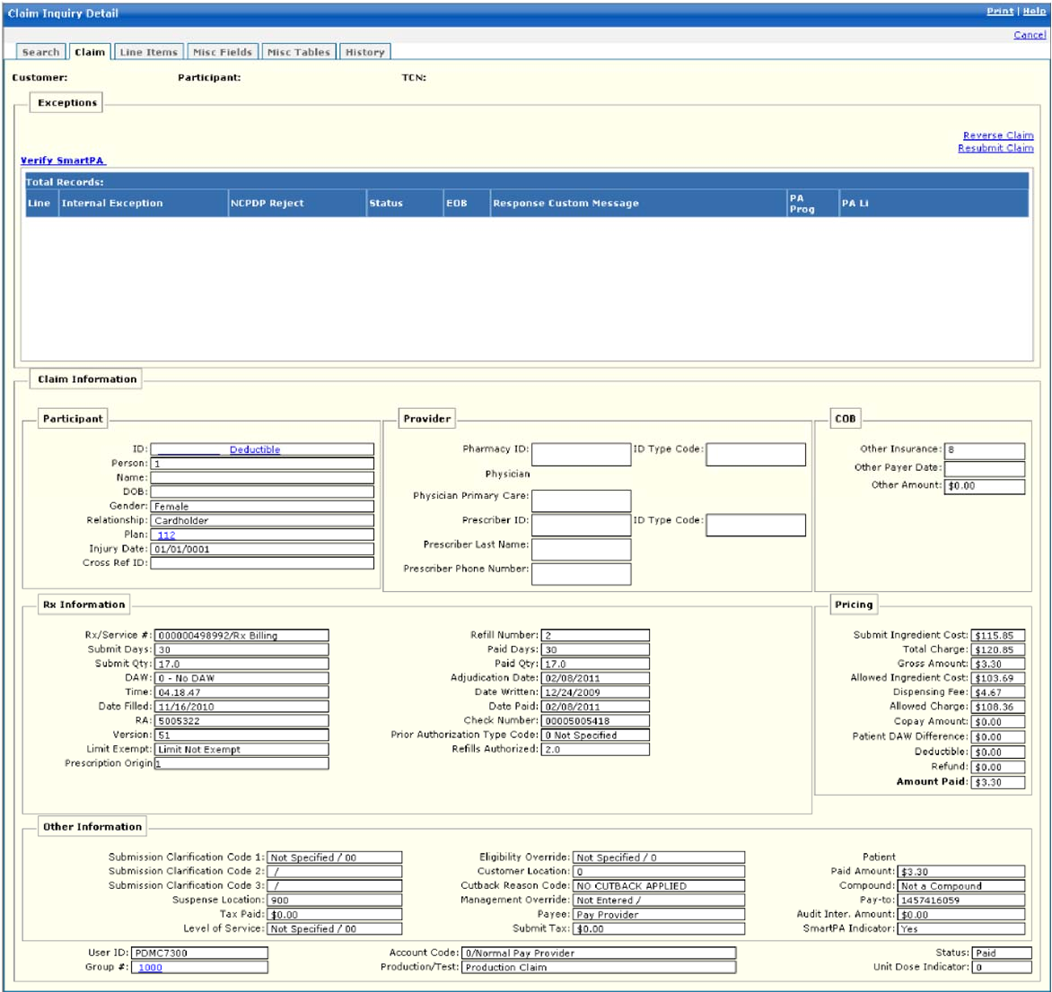

New Mexico PDCS OS PLUS Claims Subsystem
Window Exhibit
Inquiry Functional Group
Claim Window
Field Name | Table Column Name | Table Name | Format | Prot. (A,C,N) | Req.  (A,C,N) | Std. Edits | Specifications | Note  Ref.
Customer | R_CUST_NAM & R_CUST_ID | R_CUST_DTL_TB | Display | A | N | N/A | This field is populated based on the Customer ID chosen upon login.
Participant | B_LAST_NAM  B_FST_NAM  B_MI_NAM  B_ALT_ID | B_DETAIL_NM  B_ALT_ID_TB | Display | N | N | N/A | This field is populated after a search is performed. If the search returns valid results the participant name and ID are populated.
TCN | C_TCN_NUM | C_LI_DRUG_TB | Display | N | N | N/A | This field is populated after a search is performed and displays the TCN
Exceptions | N/A | N/A | Display | N/A | N/A | N/A | Grouping
Line | C_LI_NUM | C_LI_EXC_TB | 9(4),  Link | A | N | N/A | Click on the claim line number link to display the Claim Exception tab for the exception code.
Internal Exception | R_CLM_EXC_CD | C_LI_EXC_TB | X(4) | A | N | N/A | Valid Value 1737  Exception code and description
NCPDP Reject | R_CLM_ADJUD_REJ_CD | C_LI_EXC_TB | X(3) | A | N | N/A | Valid Value 4453  National standard code
Status | C_EXC_STAT_CD | C_LI_EXC_TB | X(1) | A | N | N/A | Valid Value 4200  Disposition of exception code
EOB | R_EXC_EOB_ADJUD_CD | C_LI_EXC_TB | X(4) | A | N | N/A | Code for text that appears on RA
Response Custom Message | R_NCPDP_MSG_TX | R_CLM_EXC_RESP_TB | X(175) | A | N | N/A | Message returned to pharmacy submitting claim
PA Prog | A_PA_PROG_CD | C_LI_EXC_TB | X(12) | A | N | N/A | Valid Value 3003  Name of the Drug/PA program associated with the posted exception
PA Li | A_PA_PROG_LI_NUM | C_LI_EXC_TB | 9(4) | A | N | N/A | Line number on the Drug/PA program
Total Records | N/A | N/A | Display | A | N | N/A | Computed as total number of exception set for the claim
Claim Information | N/A | N/A | Display | N/A | N/A | N/A | Grouping
Participant | N/A | N/A | Display | N/A | N/A | N/A | Grouping
ID | B_CRDHLDR_ALT_ID | C_LI_DRUG_TB | X(20),  Link | A | N | N/A | Click on the Participant ID link to display the Member tab for the Participant.  Click on the “Deductible” link to display the Benefit Limits tab for the Participant. | R1
Deductible | C_HDR_DRUG_DED_AMT | C_LI_DRUG_TB | X(11,2) | A | N | N/A
Person | B_MBR_NUM | C_LI_DRUG_TB | 9(4) | A | N | N/A | Always “1”
Name | B_FST_NAM  B_LST_NAM | C_HDR_TB | X(15)  X(21) | A | N | N/A | First and Last Name
DOB | B_DOB_DT | C_HDR_TB | DATE | A | N | N/A | Format: MM/DD/CCYY  Participant birth date
Gender | B_GENDER_CD | C_HDR_TB | X(1) | A | N | N/A | Valid Value 0229
Relationship | C_PAT_REL_CD | C_HDR_TB | 9(4) | A | N | N/A | Valid Value 0871  Always “Cardholder”
Plan | R_PLAN_ID | C_LI_DRUG_TB | X(3), Link | A | N | N/A | Benefit Plan ID - Link
Injury Date | C_HDR_INJURY_DT | C_HDR_TB | DATE | A | N | N/A | Format: MM/DD/CCYY | C1
Cross Ref ID | C_HDR_DRUG_XREF_CD | C_HDR_DRUG_TB | X(15) | A | N | N/A | Alternate Participant ID
Provider | N/A | N/A | Display | N/A | N/A | N/A | Grouping
Pharmacy ID | P_SVC_PHARM_ALT_ID | C_LI_DRUG_TB | X(15),  Link | A | N | N/A | Click on this link to display the Pharmacy tab for the submitting pharmacy.
ID Type Code | P_SVC_PH_ALT_ID_CD | C_LI_DRUG_TB | X(2) | A | N | N/A | Valid Value 2325
Physician Primary Care | P_PC_ALT_ID | C_HDR_TB | X(15) | A | N | N/A
Prescriber ID | P_PRSC_ALT_ID | C_LI_DRUG_TB | X(15),  Link | A | N | N/A | Click on this link to display the Provider tab for the prescribing prescriber.
ID Type Code | P_PRSC_ALT_ID_CD | C_LI_DRUG_TB | X(2) | A | N | N/A | Valid Value 2325
COB | N/A | N/A | Display | N/A | N/A | N/A | Grouping
Other Insurance | C_PAYERID_CD | C_HDR_COB_ID_TB | X(2) | A | N | N/A | Valid Value 2337
Other Payer Date | C_PAYERID_DT | C_HDR_COB_ID_TB | DATE | A | N | N/A | Format: MM/DD/CCYY
Other Amount | C_PAYERID_PD_AMT | C_HDR_COB_PAID_TB | 9(9)V99 | A | N | N/A
Rx Information | N/A | N/A | Display | N/A | N/A | N/A | Grouping
Rx/Service # | C_RX_SVC_REF_NUM | C_LI_DRUG_TB | 9(12) | A | N | N/A
Submit Days | C_SUB_DAY_SPLY_AMT | C_LI_DRUG_TB | 9(3) | A | N | N/A
Submit Qty | C_DRUG_SUB_QTY_AMT | C_LI_DRUG_TB | 9(3) | A | N | N/A
DAW | C_DAW_CD | C_HDR_DRUG_TB | X(1) | A | N | V | Valid Value 0246
Time | C_ADJUD_TM | C_HDR_TB | TIME | A | N | N/A
Date Filled | C_HDR_SVC_FST_DT | C_LI_DRUG_TB | DATE | A | N | N/A | Format: MM/DD/CCYY
RA | C_HDR_RA_NUM | C_HDR_TB | 9(9) | A | N | N
Version | C_DRUG_VERSN_NUM | C_HDR_DRUG_TB | X(2) | A | N | N/A
Limit Exempt | R_RX_LMT_EXMT_CD | C_LI_DRUG_TB | X(1) | A | N | V | Valid Value 7201
Prescription Origin | C_RX_ORGN_CD | C_HDR_DRUG_TB | X(1) | N | N | N/A | Valid values 3422
Refill Number | C_RX_REFILL_NUM | C_HDR_DRUG_TB | 9(2) | A | N | N/A
Paid Days | C_PD_DAYS_SPLY_AMT | C_LI_DRUG_TB | 9(3) | A | N | N/A
Paid Qty | C_HDR_PD_QTY_AMT | C_LI_DRUG_TB | 9(3) | A | N | N/A
Adjudication Date | C_HDR_ADJUD_DT | C_LI_DRUG_TB | DATE | A | N | N/A | Format: MM/DD/CCYY
Date Written | C_DRUG_PRESCR_DT | C_LI_DRUG_TB | DATE | A | N | N/A | Format: MM/DD/CCYY
Date Paid | C_HDR_PD_DT | C_LI_DRUG_TB | DATE | A | N | N/A | Format: MM/DD/CCYY
Check Number | C_HDR_WARR_NUM | C_HDR_WARRANT_TB | X(11) | A | N | N/A
Prior Authorization Type Code | C_PA_TYP_CD | C_LI_DRUG_TB | 9(4) | A | N | V | Valid Value 0596
Refills Authorized | C_REFIL_AUTH_NUM | C_HDR_DRUG_TB | 9(2) | A | N | N/A
Pricing | N/A | N/A | Display | N/A | N/A | N/A | Grouping
Submit Ingredient Cost | C_SUBM_ING_CST_AMT | C_LI_DRUG_TB | 9(7)V99 | A | N | N/A
Total Charge | C_TOT_CHRG_AMT | C_LI_DRUG_TB | 9(9)V99 | A | N | N/A
Gross Amount | C_DRUG_GROSS_AMT | C_HDR_DRUG_TB | 9(5)V99 | A | N | N/A
Allowed Ingredient Cost | C_LI_ING_ALLOW_AMT | C_LI_DRUG_TB | 9(7)V99 | A | N | N/A
Dispensing Fee | C_DISP_FEE_AMT | C_LI_DRUG_TB | 9(9)V99 | A | N | N/A
Allowed Charge | C_CALC_ALLOW_AMT | C_LI_DRUG_TB | 9(9)V99 | A | N | N
Copay Amount | C_TOT_COPAY_AMT | C_LI_DRUG_TB | 9(9)V99 | A | N | N/A
Patient DAW Difference | C_PAT_DAW_DIF_AMT | C_HDR_DRUG_TB | 9(9)V99 | A | N | N/A
Deductible | C_HDR_DRUG_DED_AMT | C_LI_DRUG_TB | 9(9)V99 | A | N | N/A
Refund | C_REFUND_AMT | C_HDR_DRUG_TB | 9(9)V99 | A | N | N/A
Amount Paid | C_TOT_REIMB_AMT | C_LI_DRUG_TB | 9(9)V99 | A | N | N/A
Other Information | N/A | N/A | N/A | A | N/A | N/A | Grouping
Submission Clarification Code 1 | C_DRUG_RX_OVRRD_CD | C_LI_DRUG_TB | X(2) | A | N | N/A | Valid Value 0874
Submission Clarification Code 2 | C_DRUG_RX_OVRRD_CD2 | C_LI_DRUG_TB | X(2) | A | N | N/A | Valid Value 0874
Submission Clarification Code 3 | C_DRUG_RX_OVRRD_CD3 | C_LI_DRUG_TB | X(2) | A | N | N/A | Valid Value 0874
Suspense Location | C_EXC_LOCN_CD | C_HDR_TB | X(3) | A | N | N/A
Tax Paid | C_DRUG_SLS_TAX_AMT | C_HDR_DRUG_TB | 9(5)V99 | A | N | N/A
Level of Service | C_LVL_OF_SVC_CD | C_HDR_DRUG_TB | 9(4) | A | N | N/A | Valid Value 4468
Eligibility Override | C_ELIG_OVRRD_IND | C_HDR_DRUG_TB | X(1) | A | N | N/A | Valid Value 0882
Customer Location | C_PAT_LOC_CD | C_HDR_TB | 9(2) | A | N | N/A | Valid Value 5668
Cutback Reason Code | C_CTBCK_RSN_CD | C_LI_DRUG_TB | X(1) | A | N | N/A | Valid Value 5426
Management Override | C_MGMT_OVRRD_IND | C_HDR_DRUG_TB | X(1) | A | N | N/A | Valid Value 1112
Payee | C_DRUG_PAYEE_CD | C_HDR_DRUG_TB | X(1) | A | N | N/A | Valid Value 0857
Submit Tax | C_SUBM_TAX_AMT | C_HDR_DRUG_TB | 9(5)V99 | A | N | N/A
Patient Paid Amount | C_PAT_LIAB_AMT | C_LI_DRUG_TB | 9(9)V99 | A | N | N/A
Compound | C_DRUG_CMPND_CD | C_LI_DRUG_TB | X(1) | A | N | N/A | Valid Value 0824
Pay to | P_PAY_TO_PROV_NUM | C_LI_DRUG_TB | X(15) | A | N | N/A
Audit Inter. Amount | C_AUD_INTRST_AMT | C_HDR_TB | 9(9)V99 | A | N | N/A
SmartPA Indicator | C_SPA_PRCS_CD | C_LI_DRUG_TB | X(1) | A | N | N/A | If the claim was processed with the Smart PA system.
User ID | G_AUD_USER_ID | C_HDR_TB | X(20) | A | N | N/A
Group # | R_GROUP_ID | C_HDR_TB | X(8),  Link | A | N | N/A | Click on the Group ID link to display the Group tab in the Customer/Group/Plan menu.
Account Code | C_BAT_PYMT_TY_CD | C_LI_DRUG_TB | X(1) | A | N | N/A | Valid Value 0070
Production/Test | C_DRUG_TEST_IND | C_LI_DRUG_TB | X(1) | A | N | N/A | Indicates Production or Test claim.  Valid Value 0877
Status | C_HDR_STAT_CD | C_LI_DRUG_TB | X(1) | A | N | N/A | Indicates Paid or Denied status.  Valid Value 1020
Unit Dose | C_UNIT_DOSE_CD | C_HDR_DRUG_TB | X(1) | A | N | N/A | Valid Value 3575

Legend
Prot. and Req. | Standard Edits | Note Ref.
A = Always | D = Date Edit | C = Customer-specific field or functionality
C = Conditionally | N = Numeric Edits | R = Note Reference
N = Never | S = System Generated
 | V = Valid Value Edit

Ref. No. | Notes
R1 | The Participant ID field contains 2 links: the Participant ID number links to the Member tab for that Participant; the “Deductible” link displays the Benefit Limits tab for the participant.
C1 | The Injury Date field is designed to track workers compensation program claims, and is not being utilized for New Mexico.

New Mexico PDCS OS PLUS Claims Subsystem
Window Specification
Inquiry Functional Group
Line Items Window

Window Name: Inquiry: Line Items
Description:
The Pharmacy Line Items Window is presented to authorized users to view pharmacy claim line item data.

If the claim is for a multiline (multi-ingredient) compound drug, a record for each ingredient is displayed. If the claim is for a single-ingredient drug, only one record appears.

Claim Information such as Ingredient Drug NDC and Name, Quantity, Ingredient Cost, and Allowed charge is displayed in the list box. Clicking a line item link displays additional information from the drug file at the bottom of the page (such as Generic Code, GSN, and GPI).

If a PA Number was submitted on the claim, or a PA number was found during adjudication, then the related Conduent PA Number will be displayed on the line item record.

Each record contains a National Drug Code (NDC) link, which takes the user to the Reference subsystem to view Drug file details on federal legend and over-the counter drugs approved by the Food and Drug Administration.

Window Type:
Response Window

Navigation:
The user enters this window by selecting the Line Items tab while in claim inquiry.

Interface to Other Subsystem(s):
PDCS OS PLUS Reference (Drug file) via NDC link

Interface to Other Application(s):
N/A

Special Security Requirements:
N/A

Presentation Sequence(s):
N/A

Remarks:
N/A

New Mexico PDCS OS PLUS Claims Subsystem
Window Layout
Inquiry Functional Group
Line Items Window

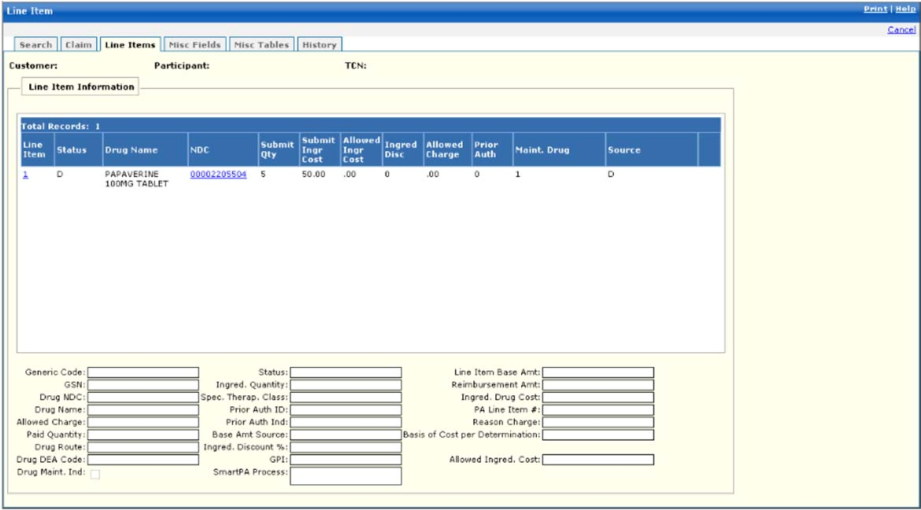

New Mexico PDCS OS PLUS Claims Subsystem
Window Exhibit
Inquiry Functional Group
Line Items Window
Field Name | Table Column Name | Table Name | Format | Prot. (A,C,N) | Req.  (A,C,N) | Std. Edits | Specifications | Note  Ref.
Customer | R_CUST_NAM & R_CUST_ID | R_CUST_DTL_TB | Display | A | N | N/A | This field is populated based on the Customer ID chosen upon login.
Participant | B_LAST_NAM  B_FST_NAM  B_MI_NAM  B_ALT_ID | B_DETAIL_NM  B_ALT_ID_TB | Display | N | N | N/A | This field is populated after a search is performed. If the search returns valid results the participant name and ID are populated.
TCN | C_TCN_NUM | C_LI_DRUG_TB | Display | N | N | N/A | This field is populated after a search is performed and displays the TCN
Line Item Information Display | Group | N/A | Grid | N/A | N/A | N/A | Grouping
Line Item | C_LI_NUM | C_LI_DRUG_TB | 9(2),  Link | A | N | N/A | Click on this link to display additional data in the bottom half of the window.
Status | C_REIMB_STAT_CD | C_LI_DRUG_TB | X(1) | A | N | N/A | Valid Value 0162
Drug Name | R_DRUG_NAM | C_LI_DRUG_TB | X(30) | A | N | N/A
NDC | R_DRUG_CD | C_LI_DRUG_TB | X(11),  Link | A | N | N/A | Click on the link to display the Drug tab within the Reference subsystem with detailed information on the NDC.
Submit Qty | C_SUBM_ING_QTY_AMT | C_LI_DRUG_TB | S9(8)v9  (3) | A | N | N/A
Submit Ingr Cost | C_SUBM_ING_CST_AMT | C_LI_DRUG_TB | S9(7)v9  (2) | A | N | N/A
Allowed Ingr Cost | C_LI_ING_ALLOW_AMT | C_LI_DRUG_TB | S9(9)v9  (2) | A | N | N/A
Ingred Disc | C_INGRED_DISCT_PCT | C_LI_DRUG_TB | S9(5)v9  (2) | A | N | N/A
Allowed Charge | C_LI_ALLOW_AMT | C_LI_DRUG_TB | S9(9)v9  (2) | A | N | N/A
Prior Auth | A_ID | C_LI_DRUG_TB | 9(11) | A | N | N/A
Maint. Drug | C_DRUG_MAINT_IND | C_LI_DRUG_TB | X(1) | A | N | N/A | Valid Value 0848
Source | C_BSE_AMT_SRC_CD | C_LI_DRUG_TB | X(2) | A | N | N/A | Valid Value 0167
Total Records | N/A | N/A | Display | A | N | N/A | Computed as total number of lines for the claim
Line Item Information Entry | Group | N/A | Grid | N/A | N/A | N/A | Grouping
Generic Code | C_DRUG_GEN_CD_NUM | C_LI_DRUG_TB | X(5) | A | N | N/A
GSN | R_DRUG_GCN_SEQ_NUM | C_LI_DRUG_TB | X(6) | A | N | N/A
Drug NDC | R_DRUG_CD | C_LI_DRUG_TB | X(11),  Link | A  N | N | N/A | This field contains a link and textbox. The textbox displays the Drug NDC. Click on the link to display the Drug tab within the Reference subsystem with detailed information on the NDC.
Drug Name | R_DRUG_NAM | C_LI_DRUG_TB | X(30) | A | N | N/A
Allowed Charge | C_CALC_ALLOW_AMT | C_LI_DRUG_TB | S9(9)v9  (2) | A | N | N/A
Paid Quantity | C_DRUG_PD_QTY_AMT | C_LI_DRUG_TB | S9(8)v9  (3) | A | N | N/A
Drug Route | C_DRUG_ROUTE_CD | C_LI_DRUG_TB | X(1) | A | N | N/A | Valid Value 0872
Drug DEA Code | C_DRUG_DEA_CD | C_LI_DRUG_TB | X(1) | A | N | N/A | Valid Value 0314
Drug Maint. Ind | C_DRUG_MAINT_IND | C_LI_DRUG_TB | Check Box | A | N | N/A | Valid Value 0848
Status | C_REIMB_STAT_CD | C_LI_DRUG_TB | X(1) | A | N | N/A | Valid Value 0162
Ingred Quantity | C_SUBM_ING_QTY_AMT | C_LI_DRUG_TB | S9(8)v  (3) | A | N | N/A
Spec. Therap. Class | R_DRG_THR_CHAR3_CD | C_LI_DRUG_TB | X(3) | A | N | N/A | Valid Value 1804
Prior Auth ID | A_ID | C_LI_DRUG_TB | S9(11) | A | N | N/A
Prior Auth Ind | C_PRIOR_AUTH_IND | C_LI_DRUG_TB | X(1) | A | N | N/A | Valid Value 1142
Base Amt. Source | C_BSE_AMT_SRC_CD | C_LI_DRUG_TB | X(2) | A | N | N/A | Valid Value 0167
Ingred Discount % | C_INGRED_DISCT_PCT | C_LI_DRUG_TB | S9(1)v  (4) | A | N | N/A
GPI | R_DRUG_GEN_PRD_CD | C_LI_DRUG_TB | X(1) | A | N | N/A | Valid Value 1839
SmartPA Process | C_SPA_PRCS_CD | C_LI_DRUG_TB | X(1) | A | N | N/A | If the claim was processed with the Smart PA system.
Line Item Base Amt | C_LI_BSE_AMT | C_LI_DRUG_TB | S9(7)v9  (2) | A | N | N/A
Reimbursement Amt | C_LI_REIMB_AMT | C_LI_DRUG_TB | S9(7)v  (2) | A | N | N/A
Ingred Drug Cost | C_SUBM_ING_CST_AMT | C_LI_DRUG_TB | S9(7)v  (2) | A | N | N/A
PA Line Item # | A_LI_NUM | C_LI_DRUG_TB | S9(2) | A | N | N/A |  | C2
Reason Charge | C_LI_ALLOW_AMT | C_HDR_DRUG_TB | S9(9)v9(2) | A | N | N/A
Basis of Cost per Determination | C_BASIS_COST_CD | C_LI_DRUG_TB | X(2) | A | N | N/A | Valid Value 9136
Allowed Ingred Cost | C_ALLW_INGRED_AMT | C_HDR_DRUG_TB | 9(9)V99 | A | N | N/A

Legend
Prot. and Req. | Standard Edits | Note Ref.
A = Always | D = Date Edit | C = Customer-specific field or functionality
C = Conditionally | N = Numeric Edits | R = Note Reference
N = Never | S = System Generated
 | V = Valid Value Edit

Ref. No. | Notes
N/A | N/A
C1 | For New Mexico, the Carrier ID is not a part of the join for a claim inquiry query. This means that the Carrier ID field is blank on the Line Items detail info window. This prevents line items from being duplicated when there are multiple carriers associated with the participant. Users can still see all of the COB carrier info in the Participant subsystem, and if there is COB involved with a specific claim, that data is on the claim information tab.
C2 | If a PA number is found during adjudication, then the Conduent PA number will display here; otherwise, the submitted PA number will display. For example, the pharmacy submits a CMS PA Number (required for CMS claims), and the PA is found. The corresponding Conduent PA number will be displayed. If the CMS PA is not found in OS PLUS, then the claim will deny and the submitted PA number will display.

New Mexico PDCS OS PLUS Claims Subsystem
Window Specification
Inquiry Functional Group
Miscellaneous Fields Window

Window Name: Inquiry: Miscellaneous Fields
Description:
The Miscellaneous Fields window contains additional claim data submitted by the pharmacy, and is used to support several NCPDP 5.1 claim format functions, including partial fills and multi-line compounds.

Window Type:
Response Window

Navigation:
The user enters this window by selecting the Misc. Fields tab while in Claim Inquiry.

Interface to Other Subsystem(s):
N/A

Interface to Other Application(s):
N/A

Special Security Requirements:
N/A

Presentation Sequence(s):
N/A

Remarks:
N/A

New Mexico PDCS OS PLUS Claims Subsystem
Window Layout
Inquiry Functional Group
Miscellaneous Fields Window

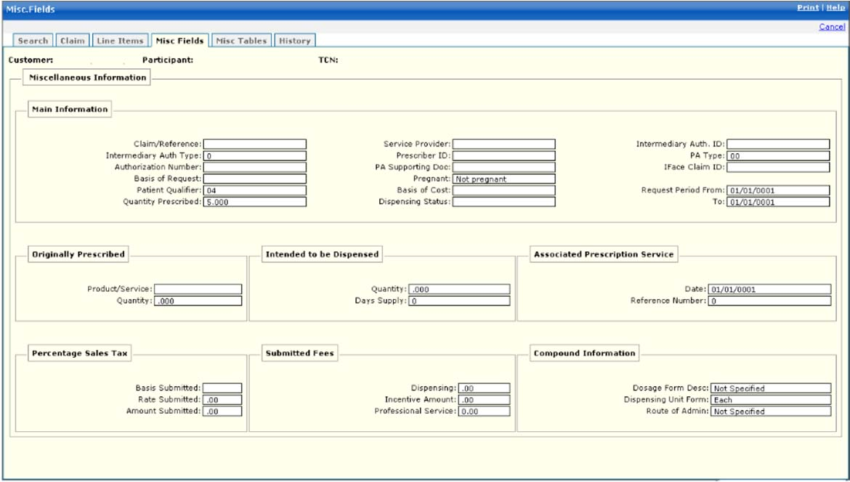

New Mexico PDCS OS PLUS Claims Subsystem
Window Exhibit
Inquiry Functional Group
Miscellaneous Fields Window
Field Name | Table Column Name | Table Name | Format | Prot. (A,C,N) | Req.  (A,C,N) | Std. Edits | Specifications | Note  Ref.
Customer | R_CUST_NAM & R_CUST_ID | R_CUST_DTL_TB | Display | A | N | N/A | This field is populated based on the Customer ID chosen upon login.
Participant | B_LAST_NAM  B_FST_NAM  B_MI_NAM  B_ALT_ID | B_DETAIL_NM  B_ALT_ID_TB | Display | N | N | N/A | This field is populated after a search is performed. If the search returns valid results the participant name and ID are populated.
TCN | C_TCN_NUM | C_LI_DRUG_TB | Display | N | N | N/A | This field is populated after a search is performed and displays the TCN
Line Item Information Display | N/A | N/A | N/A | N/A | N/A | N/A | Grouping
Main Information | Group | N/A | Display | N/A | N/A | N/A | Grouping
Claim/Reference | C_CLM_REF_ID_NUM | C_HDR_TB | X(30) | A | N | N/A
Intermediary Auth Type | C_INTMDRY_AUTH_CD | C_HDR_TB | X(1) | A | N | N/A | Valid Value 8642
Authorization Number | A_AUTH_NUM | C_HDR_TB | X(20) | A | N | N/A
Basis of Request | C_PA_BASIS_REQ_CD | C_HDR_TB | X(2) | A | N | N/A | Valid Value 9032
Patient Qualifier | B_CRDHLD_ALT_ID_CD | C_LI_DRUG_TB | X(2) | A | N | N/A | Valid Value 0255
Quantity Prescribed | C_QTY_PRSC_AMT | C_HDR_DRUG_TB | 9(7)V99 | A | N | N/A
Service Provider | P_PHARM_ALT_ID | C_HDR_DRUG_TB | X(15) | A | N | N/A
Prescriber ID | P_PRSC_ALT_ID | C_LI_DRUG_TB | X(15) | A | N | N/A
PA Supporting Doc | C_PA_SUP_DOC_TX | C_HDR_TB | X(70) | A | N | N/A
Pregnant | C_PRGNCY_IND | C_HDR_TB | X(1) | A | N | N/A | Valid Value 9269
Basis of Cost | C_BASIS_COST_CD | C_LI_DRUG_TB | X(2) | A | N | N/A | Valid Value 9136
Dispensing Status | C_DISP_STATUS_CD | C_LI_DRUG_TB | X(1) | A | N | N/A | Valid Value 8723
Intermediary Auth. ID | C_INTMDRY_AUTH_ID | C_HDR_TB | X(11) | A | N | N/A | Valid Value 8642
PA Type | C_PA_TYP_CD | C_LI_DRUG_TB | 9(1) | A | N | N/A | Valid Value 0596
Iface Claim ID | C_IFACE_CLM_ID | C_HDR_TB | X(30) | A | N | N/A
Request Period From | C_PA_REQ_BEG_DT | C_HDR_TB | DATE | A | N | N/A | Format: MM/DD/CCYY
Request Period To | C_PA_REQ_END_DT | C_HDR_TB | DATE | A | N | N/A | Format: MM/DD/CCYY
Originally Prescribed | Group | N/A | Display | N/A | N/A | N/A | Grouping
Product/Service | C_ORG_PROD_SVC_ID | C_HDR_DRUG_TB | X(19) | A | N | N/A
Quantity | C_ORG_QTY_PRSC_AMT | C_HDR_DRUG_TB | 9(7)V99 | A | N | N/A
Intended to be Dispensed | Group | N/A | Display | N/A | N/A | N/A | Grouping
Quantity | C_INT_DISP_QTY_AMT | C_HDR_DRUG_TB | 9(7)V99 | A | N | N/A
Days Supply | C_INT_DISP_DAY_NUM | C_HDR_DRUG_TB | 9(3) | A | N | N/A
Associated Prescription Service | Group | N/A | Display | N/A | N/A | N/A | Grouping
Date | C_ASOC_RX_SVC_DT | C_HDR_DRUG_TB | DATE | A | N | N/A | Format: MM/DD/CCYY
Reference Number | C_ASOC_RX_SVC_NUM | C_HDR_DRUG_TB | 9(9) | A | N | N/A
Percentage Sales Tax | Group | N/A | Display | N/A | N/A | N/A | Grouping
Basis Submitted | C_SUBM_PCT_TX_CD | C_HDR_DRUG_TB | X(2) | A | N | N/A | Valid Value 2890
Rate Submitted | C_SUBM_PCT_RT_AMT | C_HDR_DRUG_TB | 9(3)V9999 | A | N | N/A
Amount Submitted | C_SUBM_PCT_TX_AMT | C_HDR_DRUG_TB | 9(7)V99 | A | N | N/A
Submitted fees | Group | N/A | Display | N/A | N/A | N/A | Grouping
Dispensing | C_SUBM_DSP_FEE_AMT | C_HDR_DRUG_TB | 9(7)V99 | A | N | N/A
Incentive Amount | C_SUBM_INCNTVE_AMT | C_HDR_DRUG_TB | 9(7)V99 | A | N | N/A
Professional Services | C_SUBM_PRO_FEE_AMT | C_HDR_DRUG_TB | 9(7)V99 | A | N | N/A
Compound Information | Group | N/A | Display | N/A | N/A | N/A | Grouping
Dosage Form Desc | C_DSG_FM_DESC_CD | C_HDR_DRUG_TB | X(2) | A | N | N/A | Valid Value 7054
Dispensing Unit Form | C_DISP_UNT_FM_CD | C_HDR_DRUG_TB | X(1) | A | N | N/A | Valid Value 8811
Route of Admin | C_CLM_RT_OF_ADMIN_CD | C_HDR_DRUG_TB | X(11) | A | N | N/A | Valid Value 9532

Legend
Prot. and Req. | Standard Edits | Note Ref.
A = Always | D = Date Edit | C = Customer-specific field or functionality
C = Conditionally | N = Numeric Edits | R = Note Reference
N = Never | S = System Generated
 | V = Valid Value Edit

Ref. No. | Notes
N/A | N/A
New Mexico PDCS OS PLUS Claims Subsystem
Window Specification
Inquiry Functional Group
Miscellaneous Tables Window
Window Name: Inquiry: Miscellaneous Tables
Description:
The Miscellaneous Tables window is presented to authorized users to view pharmacy claim data. Authorized users utilize the Pharmacy Miscellaneous Tables window to inquire on claim information tied directly to possible repeating segments. The Miscellaneous Tables window contains information pertaining to DUR, Procedure Modifier codes associated with physician services, Other Amounts associated with additional costs incurred for a dispensed prescription or service, Clinical information, Diagnosis Code and COB Paid/Reject information.
Window Type:
Response Window
Navigation:
The user enters this window selecting the Misc. Tables tab while in Claim Inquiry.
Interface to Other Subsystem(s):
N/A
Interface to Other Application(s):
N/A
Special Security Requirements:
N/A
Presentation Sequence for DUR/PPS:
DUR/PPS Line Item number
Presentation Sequence for Procedure Modifier:
Procedure Modifier Line Item number
Presentation Sequence for Clinical:
Clinical Line Item number
Presentation Sequence for COB/Other Payer:
Other Payer Coverage Line Item number
Presentation Sequence for Other Amount:
Other Payer Coverage Line Item number
Presentation Sequence for COB Reject:
Other Payer Coverage Line Item number
Presentation Sequence for Other Amount:
Other Payer Coverage Line Item number
Presentation Sequence for Diagnosis:
Diagnosis Code Line Item Number
Presentation Sequence for COB Paid:
Other Payer Coverage Line Item number
Remarks:
N/A

New Mexico PDCS OS PLUS Claims Subsystem
Window Layout
Inquiry Functional Group
Miscellaneous Tables Window
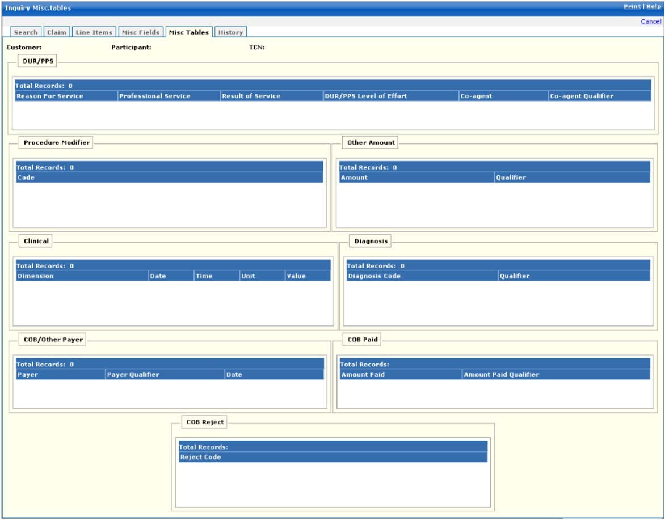

New Mexico PDCS OS PLUS Claims Subsystem
Window Exhibit
Inquiry Functional Group
Miscellaneous Tables Window
Field Name | Table Column Name | Table Name | Format | Prot. (A,C,N) | Req.  (A,C,N) | Std. Edits | Specifications | Note  Ref.
Customer | R_CUST_NAM & R_CUST_ID | R_CUST_DTL_TB | Display | A | N | N/A | This field is populated based on the Customer ID chosen upon login.
Participant | B_LAST_NAM  B_FST_NAM  B_MI_NAM  B_ALT_ID | B_DETAIL_NM  B_ALT_ID_TB | Display | N | N | N/A | This field is populated after a search is performed. If the search returns valid results the participant name and ID are populated.
TCN | C_TCN_NUM | C_LI_DRUG_TB | Display | N | N | N/A | This field is populated after a search is performed and displays the TCN
DUR/PPS | N/A | N/A | Display | N/A | N/A | N/A | Grouping
Reason for Service | R_RSN_FOR_SVC_CD | C_HDR_DUR_PPS_TB | X(2) | A | N | N/A | Valid Value 8605
Professional Service | C_DUR_PPS_CD | C_HDR_DUR_PPS_TB | X(2) | A | N | N/A | Valid Value 0834
Result of Service | C_DUR_RSLT_SVC_CD | C_HDR_DUR_PPS_TB | X(2) | A | N | N/A | Valid Value 0881
DUR PPS Level of Effort | C_DUR_LVL_EFRT_CD | C_HDR_DUR_PPS_TB | 9(2) | A | N | N/A | Valid Value 4634
Co- agent | C_DUR_CO_AGT_ID | C_HDR_DUR_PPS_TB | X(19) | A | N | N/A
Co- agent Qualifier | C_DUR_CO_AGT_ID_CD | C_HDR_DUR_PPS_TB | X(2) | A | N | N/A | Valid Value 4197
Total Records | N/A | N/A | Display | A | N | N/A | Computed as total number of DUR/PPS segments for claim
Procedure Modifier | N/A | N/A | Display | N/A | N | N/A
Code | R_PROC_MOD_CD | C_HDR_PROC_MOD_TB | X(2) | A | N | N/A | Valid Value 0139
Total Records | N/A | N/A | Display | A | N | N/A | Computed as total number of procedure modifier segments for claim
Other Amount | N/A | N/A | Display | N/A | N/A | N/A | Grouping
Amount | C_SUBM_OTHR_AMT | C_HDR_OTH_AMT_TB | 9(7)V99 | A | N | N/A
Qualifier | C_SUBM_OTHR_AMT_CD | C_HDR_OTH_AMT_TB | X(2) | A | N | N/A | Valid Value 7805
Total Records | N/A | N/A | Display | A | N | N/A | Computed as total number of other amount segments on the claim
Clinical | N/A | N/A | Display | N/A | N/A | N/A | Grouping
Dimension | C_CLIN_MSRMT_DM_CD | C_HDR_CLINICAL_TB | X(2) | A | N | N/A | Valid Value 2649
Date | C_CLIN_MSRMT_DT | C_HDR_CLINICAL_TB | DATE | A | N | N/A | Format: MM/DD/CCYY
Time | C_CLIN_MSRMT_TM | C_HDR_CLINICAL_TB | 9(4) | A | N | N/A
Unit | C_CLIN_MSRMT_UN_CD | C_HDR_CLINICAL_TB | X(2) | A | N | N/A | Valid Value 5234
Value | C_CLIN_MSRMT_DESC | C_HDR_CLINICAL_TB | X(15) | A | N | N/A
Total Records | N/A | N/A | Display | A | N | N/A | Computed as total number of clinical segments for the claim
Diagnosis | N/A | N/A | Display | N/A | N/A | N/A | Grouping
Diagnosis Code | R_DIAG_CD | C_HDR_DIAG_TB | X(10) | A | N | N/A
Qualifier | C_DIAG_QL_CD | C_HDR_DIAG_TB | X(2) | A | N | N/A | Valid Value 1284
Total Records | N/A | N/A | Display | A | N | N/A | Computed as total number of diagnosis segments for the claim
COB/Other Payer | N/A | N/A | Display | N/A | N/A | N/A
Payer | C_PAYER_ID | C_HDR_COB_ID_TB | X(10) | A | N | N/A
Payer Qualifier | C_PAYERID_CD | C_HDR_COB_ID_TB | X(2) | A | N | N/A | Valid Value 2337
Date | C_PAYERID_DT | C_HDR_COB_ID_TB | DATE | A | N | N/A | Format: MM/DD/CCYY
Total Records | N/A | N/A | Display | A | N | N/A | Computed as total number of COB payer segments for claim
COB Paid | N/A | N/A | Display | N/A | N/A | N/A | Grouping
Amount Paid | C_PAYERID_PD_AMT | C_HDR_COB_PAID_TB | S9(9)V9(2) | A | N | N/A
Amount Paid Qualifier | C_PAYERID_PD_CD | C_HDR_COB_PAID_TB | X(2) | A | N | N/A | Valid Value 8101
Total Records | N/A | N/A | Display | A | N | N/A | Computed as total number of COB paid amounts for claim
COB Reject | N/A | N/A | Display | N/A | N/A | N/A | Grouping
Reject Code | C_PAYERID_REJ_CD | C_HDR_COB_REJ_TB | X(3) | A | N | N/A | Valid Value 4717
Total Records | N/A | N/A | Display | A | N | N/A | Computed as total number of COB reject segments for claim
COB Patient Responsibility | N/A | N/A | N/A | N/A | N/A | N/A | Grouping
Patient Responsibility Amt Qualifier cd | C_COB_PAT_RESP_CD | C_HDR_COB_PAT_TB | X(3) | A | N | N/A | Valid Value 8626
Patient Responsibility Amt | C_COB_PAT_RESP_AMT | C_HDR_COB_PAT_TB | 9(8).9(2) | N | N
Total Records | N/A | N/A | Display | A | N | N/A | Computed as total number of COB Patient Responsibility values values for claim
COB Patient Responsibility entry | N/A | N/A | N/A | N/A | N/A | N/A | Grouping
Patient responsibility amt qualifier code | C_PAYERID_REJ_CD | C_HDR_COB_REJ_TB | X(3) | C | C | V | Valid Value 4717
Patient Responsibility Amt | C_COB_PAT_RESP_AMT | C_HDR_COB_PAT_TB | 9(8).9(2) | N | N
Command Buttons | Group | N/A | Button Row | N/A | N/A | N/A | Grouping
Add | N/A | N/A | Push Button | N | N | N/A | When the Add COB Patient Responsibility button is selected, the new COB Patient Responsibility row that has been entered is added.
Update | N/A | N/A | Push Button | N | N | N/A | When the Update COB Patient Responsibility button is selected, the COB Patient Responsibility row that has been changed is updated.
Delete | N/A | N/A | Push Button | N | N | N/A | When the Delete COB Patient Responsibility button is selected, the COB Patient Responsibility row that is selected is deleted. | R1
COB Benefit Stage | N/A | N/A | N/A | N/A | N/A | N/A | Grouping
Benefit Stage Qualifier cd | C_COB_BENE_ST_CD | C_HDR_COB_BENE_TB | X(3) | A | N | N/A | Valid Value 1890
Benefit Stage Amt | C_COB_BENE_ST_AMT | C_HDR_COB_BENE_TB | 9(8).9(2) | N | N
Total Records | N/A | N/A | Display | A | N | N/A | Computed as total number of COB Benefit Stage values for claim
COB Benefit Stage entry | N/A | N/A | N/A | N/A | N/A | N/A | Grouping
Benefit Stage qualifier code | C_COB_BENE_ST_CD | C_HDR_COB_BENE_TB | X(3) | C | C | V | Valid Value 4717
Benefit Stage Amt | C_COB_BENE_ST_AMT | C_HDR_COB_BENE_TB | 9(8).9(2) | N | N
Command Buttons | Group | N/A | Button Row | N/A | N/A | N/A | Grouping
Add | N/A | N/A | Push Button | N | N | N/A | When the Add COB Benefit Stage button is selected, the new COB Benefit Stage row that has been entered is added.
Update | N/A | N/A | Push Button | N | N | N/A | When the Update COB Benefit Stage button is selected, the COB Benefit Stage row that has been changed is updated.
Delete | N/A | N/A | Push Button | N | N | N/A | When the Delete COB Benefit Stage button is selected, the COB Benefit row that is selected is deleted. | R1

Legend
Prot. and Req. | Standard Edits | Note Ref.
A = Always | D = Date Edit | C = Customer-specific field or functionality
C = Conditionally | N = Numeric Edits | R = Note Reference
N = Never | S = System Generated
 | V = Valid Value Edit

Ref. No. | Notes
N/A | N/A
New Mexico PDCS OS PLUS Claims Subsystem
Window Specification
Inquiry Functional Group
History Window

Window Name: Inquiry: History
Description:
Authorized users utilize the Pharmacy History Window to view related claims.

The Related History page displays TCNs for claims that caused exception codes to post on the claim being viewed (related to DUR conflicts, duplicate checking, or refill too soon). If the claim being viewed has been reversed or adjusted, the Credit/Adjustment Information page displays the TCN of the credit or Adjustment claim. If the claim being viewed is an adjustment, the Credit/Adjustment Information page displays the TCN of the original claim.

The user can click on the TCN of each related claim to view that claim’s detail information.
Window Type:
Response Window
Navigation:
The user enters this window by selecting the History tab while in claim inquiry. A TCN link can be selected to display the related TCN.

The Credit Claim link allows authorized Conduent users to enter the Pharmacy ID associated with the claim in order to immediately credit the claim.
Interface to Other Subsystem(s):
N/A
Interface to Other Application(s):
N/A
Special Security Requirements:
N/A
Presentation Sequence for Related History:
Line Item Number
Presentation Sequence for Credit/Adjustment Information:
Line Item Number
Remarks:
N/A

New Mexico PDCS OS PLUS Claims Subsystem
Window Layout
Inquiry Functional Group
History Window

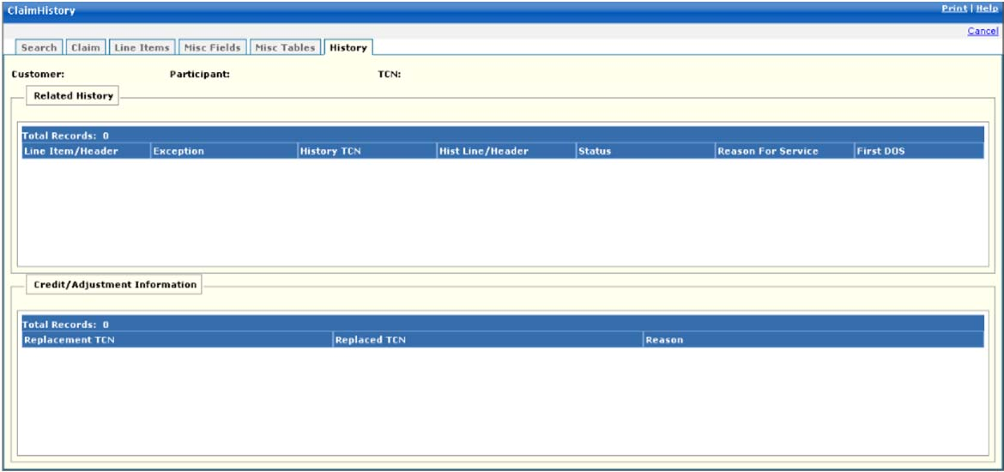

New Mexico PDCS OS PLUS Claims Subsystem
Window Exhibit
Inquiry Functional Group
History Window
Field Name | Table Column Name | Table Name | Format | Prot. (A,C,N) | Req.  (A,C,N) | Std. Edits | Specifications | Note  Ref.
Customer | R_CUST_NAM & R_CUST_ID | R_CUST_DTL_TB | Display | A | N | N/A | This field is populated based on the Customer ID chosen upon login.
Participant | B_LAST_NAM  B_FST_NAM  B_MI_NAM  B_ALT_ID | B_DETAIL_NM  B_ALT_ID_TB | Display | N | N | N/A | This field is populated after a search is performed. If the search returns valid results the participant name and ID are populated.
TCN | C_TCN_NUM | C_LI_DRUG_TB | Display | N | N | N/A | This field is populated after a search is performed and displays the TCN
Credit Claim | N/A | N/A | Link | N | N | N/A | This link is used for an adjustment to fully credit the claim back.
Related History | N/A | N/A | Display | N/A | N/A | N/A | Grouping
Line Item Header | C_LI_NUM | C_HDR_RLTD_HIST_TB | 9(4) | A | N | N/A
Exception | R_CLM_EXC_CD | C_HDR_RLTD_HIST_TB | X(4) | A | N | N/A | Valid Value 1737
History TCN | C_RLTD_LI_TCN_NUM | C_HDR_RLTD_HIST_TB | 9(17) | A | N | N/A
Hist Line/Header | C_RLTD_LI_NUM | C_HDR_RLTD_HIST_TB | 9(2) | A | N | N/A
Status | C_EXC_STAT_CD | C_HDR_RLTD_HIST_TB | X(1) | A | N | N/A | Valid Value 4200
Reason for Service | R_RSN_FOR_SVC_CD | C_HDR_RLTD_HIST_TB | X(2) | A | N | N/A | Valid Value 8605
First DOS | C_HDR_SVC_FST_DT | C_LI_DRUG_TB | DATE | A | N | N/A | Format: MM/DD/CCYY
Total Records | N/A | N/A | Display | A | N | N/A | Computed as total number of exceptions due to related claims
Credit/  Adjustment Information | N/A | N/A | Display | N/A | N/A | N/A | Grouping
Replacement TCN | C_REPLCMT_TCN_NUM | C_HDR_ADJ_VD_TB | 9(17) | A | N | N/A
Replaced TCN | C_REPLCD_TCN_NUM | C_HDR_ADJ_VD_TB | 9(17) | A | N | N/A
Reason | C_HDR_ADJ_RSN_CD | C_HDR_ADJ_VD_TB | X(3) | A | N | N/A | Valid Value 0961
Total Records | N/A | N/A | Display | A | N | N/A | Computed as total number of Adjustment claims

Legend
Prot. and Req. | Standard Edits | Note Ref.
A = Always | D = Date Edit | C = Customer-specific field or functionality
C = Conditionally | N = Numeric Edits | R = Note Reference
N = Never | S = System Generated
 | V = Valid Value Edit

Ref. No. | Notes
N/A | N/A

13.2.6.8 Suspense Correction Functional Group

Note: Suspense Correction is not used by New Mexico. Window screenshots are provided for example only.

This functional group provides the user the ability to:

- Enter selection criteria to retrieve suspended claim.
- Correct suspended claim.
- Adjudicate corrected claim.

The following tab windows are used by the Suspense Correction Functional Group:

- Correction Selection
- Exceptions/Suspense Correction Selection
- Overrides

The following data is displayed in the title bar of all tab windows (i.e., not on search windows) in this functional group:

- Customer name, Participant ID, and TCN

New Mexico PDCS OS PLUS Claims Subsystem
Window Specification
Suspense Correction Functional Group
Suspended Claim Correction Search Window

Window Name: Suspended Correction: Search
Description:
The Suspended Claim Correction Search Window allows for entry of various criteria to select suspended claims for update. The search criteria consist of Participant ID, Pharmacy Number, TCN, or Next Queued Suspense. For the Next Queued Suspense option, the user specifies the suspense queue for which to search.

List the valid primary/secondary criteria combinations.

Note: Suspense Correction is not used by New Mexico. Window screenshot provided for example only.

Window Type:
Response Window

Navigation:
The user enters this window by selecting the Suspense Correction option from the Claims subsystem menu.

Interface to Other Subsystem(s):
N/A

Interface to Other Application(s):
N/A

Special Security Requirements:

Presentation Sequence(s):
TCN Number

Remarks:
N/A

New Mexico PDCS OS PLUS Claims Subsystem
Window Layout
Suspense Correction Functional Group
Suspended Claim Correction Search Window

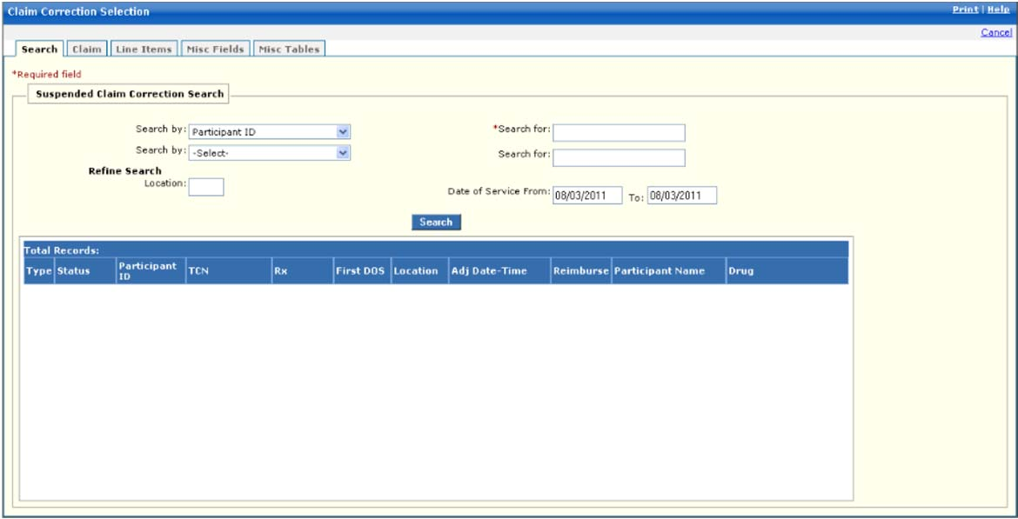

New Mexico PDCS OS PLUS Claims Subsystem
Window Specification
Suspense Correction Functional Group
Claims Window

Window Name: Suspense Correction: Claims
Description:
The Correction Selection Window allows for entry of either various criteria to affect the correction of existing claims. The system shall maintain suspended claims making them accessible for online inquiry and resolution.

Note: Suspense Correction is not used by New Mexico. Window screenshot provided for example only.

Window Type:
Response Window

Navigation:
The user enters this window by selecting the Suspense Correction menu while in the Claims subsystem. The user selects a claim for correction.

Interface to Other Subsystem(s):
N/A

Interface to Other Application(s):
N/A

Special Security Requirements:
N/A

Presentation Sequence(s):
For Exceptions – By Line #/Exception Code

Remarks:
N/A

New Mexico PDCS OS PLUS Claims Subsystem
Window Layout
Suspense Correction Functional Group
Claims Window

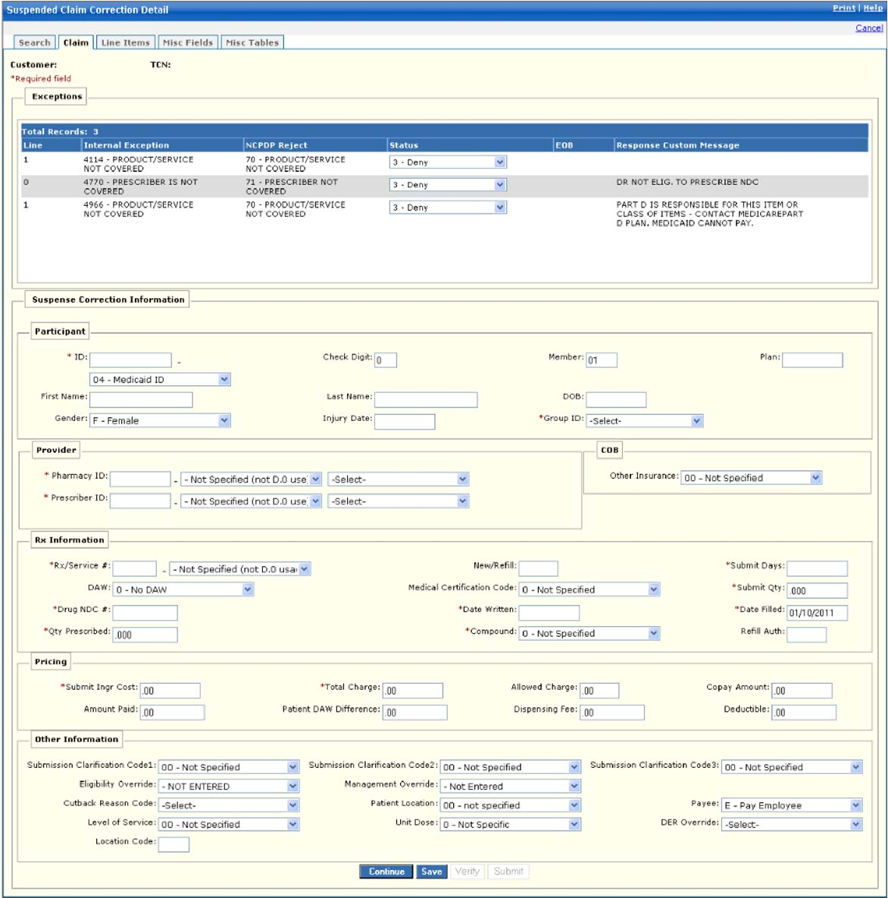
13.2.6.9 Suspense Release Functional Group

Note: Suspense Release is not used by New Mexico. Window screenshots are provided for example only.

This functional group provides the user the ability to:

- Search for Pending Suspense Release Requests
- Enter Suspense Release Requests
- Delete Suspense Release Requests

The following tab windows are used by the Suspense Release Functional Group:

- Search
- Suspense Release

The following data is displayed in the title bar of all tab windows (i.e., not on search windows) in this functional group:

- Customer Name

New Mexico PDCS OS PLUS Claims Subsystem
Window Specification
Suspense Release Functional Group
Suspense Release Search Window

Window Name: Suspense Release: Suspense Release Search
Description:
The Suspense Release Search Window is used to add, update, and delete suspense release requests. Requests to release suspended claims are processed in the nightly batch cycle. These claims are adjudicated in batch.

Note: Suspense Release is not used by New Mexico. Window screenshot provided for example only.

Window Type:
Response Window

Navigation:
The user enters this window by selecting the Suspense Release option from the Claims subsystem menu. The user clicks on the Add Release link to proceed to the Release window.

Interface to Other Subsystem(s):
N/A

Special Security Requirements:
Access to data is controlled by the user’s security profile. Results can be resorted by clicking on the Release Action header.

Presentation Sequence(s):
Suspense Release Date.

Remarks:
N/A

New Mexico PDCS OS PLUS Claims Subsystem
Window Layout
Suspense Release Functional Group
Suspense Release Search Window

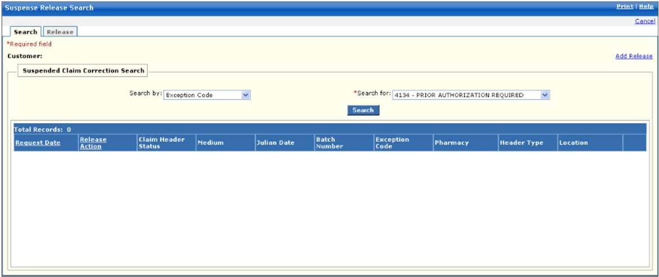
New Mexico PDCS OS PLUS Claims Subsystem
Window Specification
Suspense Release Functional Group
Release Window

Window Name: Suspense Release: Release
Description:
The Suspense Release window assists with processing groups of suspended claims. An authorized user can release a specific batch of suspended claims, release all batches of suspended claims, or delete a batch of suspended claims. There is also an option to release a specific batch and delete all claims within the batch that have a zero payment amount. When a request is entered using this window, all suspended claims meeting the specified criteria are automatically reprocessed through the nightly adjudication cycle.

Note: Suspense Release is not used by New Mexico. Window screenshot provided for example only.

Window Type:
Sheet Window

Navigation:
This window is accessed by selecting the Release tab.

Interface to Other Subsystem(s):
N/A

Interface to Other Application(s):
N/A

Special Security Requirements:
Access to data is controlled by the user’s security profile.

Presentation Sequence(s):
N/A

Remarks:
These options are used primarily for batches of claims produced by the Mass Adjustment Process. The user can also release suspended claims, regardless of batch, based on specific criteria such as exception code, suspense location code, provider, or participant ID.

New Mexico PDCS OS PLUS Claims Subsystem
Window Layout
Suspense Release Functional Group
Suspense Release Window

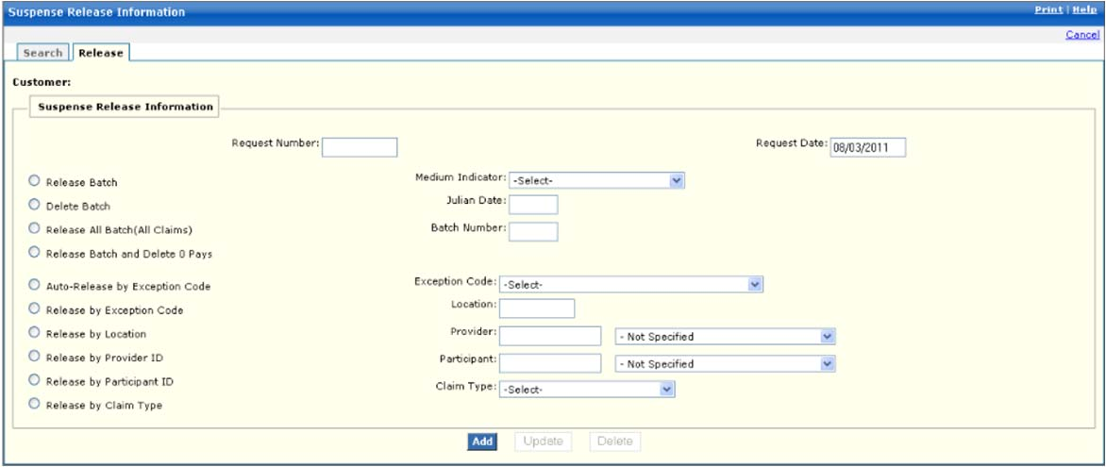

13.2.6.10 History Adjustment Functional Group

This functional group provides the user the ability to:

- Enter selection criteria to retrieve history adjustment claims.

The following tab windows are used by the History Adjustment Functional Group:

- Selection

The following data is displayed in the title bar of all tab windows (i.e., not on search windows) in this functional group:

- Customer Name and ID

New Mexico PDCS OS PLUS Claims Subsystem
Window Specification
History Adjustment Functional Group
History Adjustment Search Window

Window Name: History: History Adjustment Selection Page
Description:
The History Adjustment Search window allows users to search for adjusted claims by Participant ID, Pharmacy ID, Date of Service, or TCN. Secondary search criteria include Pharmacy ID, Participant ID, and Prescription ID. As with Claim Inquiry, users can refine the search based on prescribing ID, member number, claim type, and claim status.

Note: The History Adjustment functional group is not utilized by New Mexico.

Window Type:
Response Window

Navigation:
The user enters this window by selecting the History Adjustment menu while in the Claims subsystem.

Interface to Other Subsystem(s):
N/A

Interface to Other Application(s):
N/A

Special Security Requirements:
Access to data is controlled by the user’s security profile.

Presentation Sequence for Related History:
Transaction Control Number

Remarks:
N/A

New Mexico PDCS OS PLUS Claims Subsystem
Window Layout
History Adjustment Functional Group
History Adjustment Search Tab Page

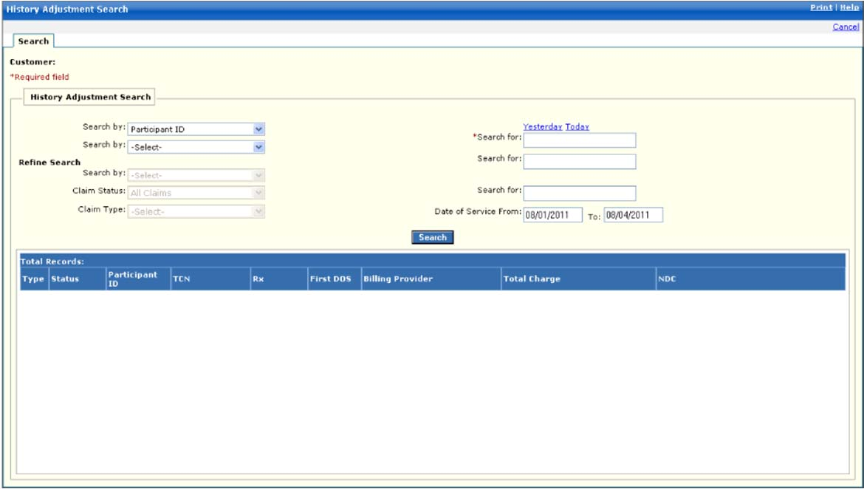

New Mexico PDCS OS PLUS Claims Subsystem
Window Exhibit
History Adjustment Functional Group
History Adjustment Search Tab Page
Field Name | Table Column Name | Table Name | Format | Prot. (A,C,N) | Req.  (A,C,N) | Std. Edits | Specifications | Note  Ref.
Customer | R-CUST-PART-NUM | B_DETAIL_NM | 9,999 | A | N/A | N/A | Display Header
History Adjustment Search Entry | Group | N/A | Free Form | N/A | N/A | N/A | Grouping
Search By (1) | N/A | N/A | N/A | N | A | N/A | Drop-down box. Valid selections presented. User must select a Search By value.  Valid Options are:  TCN  Pharmacy Number  Participant  Prescription Number
Search By (2) | N/A | N/A | N/A | A | C | N/A | Second set of defined criteria. If entered, criterion is used in combination with the values in Search By (1) and Search For (1) to search for claims. Valid Options are:  Pharmacy Number  Participant  Prescription Number  <none>
Yesterday | N/A | N/A | Link | N | N | N/A | Displays previous day’s Julian date in search for field for TCN search.
Today | N/A | N/A | Link | N | N | N/A | Displays Current Julian date in search for field for TCN search.
Search For (1) | N/A | N/A | N/A | N | N | S | The specific value of the Search By (1) criteria specified by the user. Edits for valid length depending on value of Search By (1). Wild cards are not allowed.
Search For (2) | N/A | N/A | N/A | N | C | S | The specific value of the Search By (2) criteria specified by the user. Required when Search By (2) is selected. Edits for valid length depending on value of Search By (2). Wild cards are not allowed.
Refine Search | N/A | N/A | Display | N/A | N/A | N/A | Grouping
Search By | N/A | N/A | Drop-down | N | N | N/A | Drop-down box. Valid selections presented. User must select a Search By value.  Valid Options are:  TCN  Pharmacy Number  Participant  Prescription Number
Claim Status | N/A | N/A | Drop-down | N | N | N/A | Drop-down box. Valid selection values are displayed.
Claim Type | N/A | N/A | Drop-down | N | N | N/A | Drop-down box. Valid selection values are displayed.
Search For (3) | N/A | N/A | X(8) | N | C | S | The specific value of the Search By criteria specified by the user. Required when Search By is selected. Wild cards are not allowed.
Date of Service From | N/A | N/A | DATE | N | C | D | Format: MM/DD/CCYY  User enters an earliest search date of service.  Must be a valid date
Date of Service To | N/A | N/A | DATE | N | C | D | Format: MM/DD/CCYY  User enters an earliest search date of service.  Must be a valid date
Command Button | Group | N/A | Button Row | N/A | N/A | N/A | Grouping
Search | N/A | N/A | Push Button | N | N | N/A | When pressed, claims meeting the Search Criteria entered by the user are selected from the database and displayed in the multi-column list box.
History Adjustment Search Display | Group | N/A | Display | N/A | N/A | N/A | Grouping
Type | C_ADJ_REQ_TY_CD | C_ADJ_REQ_TB | X(1) | A | N | N/A | Valid Value 0705
Status | C_HDR_STAT_CD | C_LI_DRUG_TB | X(1) | A | N | N/A | Valid Value 1020
Participant ID | B_CRDHLDR_ALT_ID | C_LI_DRUG_TB | X(20) | A | N | N/A
TCN | C_TCN_NUM | C_LI_DRUG_TB | X(17) | A | N | N/A
Rx | C_RX_SVC_REF_NUM | C_LI_DRUG_TB | 9(12) | A | N | N/A
First DOS | C_HDR_SVC_FST_DT | C_LI_DRUG_TB | DATE | A | N | N/A | Format: MM/DD/CCYY
Billing Provider | B_BLNG_PROV_ID | C_LI_DRUG_TB | X(9) | A | N | N/A
Total Charge | C_TOT_CHRG_AMT | C_LI_DRUG_TB | 9(11)v9(2) | A | N | N/A
NDC | R_DRUG_CD | C_LI_DRUG_TB | X(11) | A | N | N/A
Total Records | N/A | N/A | Display | A | N | N/A | Computed as total number of records meeting the search criteria

Legend
Prot. and Req. | Standard Edits | Note Ref.
A = Always | D = Date Edit | C = Customer-specific field or functionality
C = Conditionally | N = Numeric Edits | R = Note Reference
N = Never | S = System Generated
 | V = Valid Value Edit

Ref. No. | Notes
N/A | N/A

